Angela Maliszewski

MIS 505 - Project

Federal Student Loans Are Out of Control

**Project Overview:**

Like many High-Tech Companies, SAS Institute, Inc. requires a College Degree to be hired into most of our jobs. I work for SAS, a Software Company based out of Cary, NC. We employ more than 6,500 in the US and although we require a degree, we DO NOT CURRENTLY offer any financial assistance to our employees to pay back their student loans.

College Degrees are getting more expensive each year forcing more students to take out more substantial loans.

Since 2010, the Federal Government has granted millions of borrowers more than a trillion dollars in student loans.

For this project, I looked at Federal Direct Student Loan trends over a two-year period (from 2017 to 2019) to see how big of a problem they might become. Note: Each federal fiscal year begins October 1 and ends September 30.

I created 43 charts and 7 dashboards in Tableau to explore and explain the Federal Student Loan data I had access to. The dashboards submitted for this project are colored teal within the tableau book. The charts used are colored yellow. Yellow dashboards are mentioned in this paper but were not used for the project.

I used current trends to share my projections.

After completing this initial project for your class, I plan to complete a future project to look at SAS employee data to see how big of an issue student loans might be for our employees and provide recommendations for SAS to start a Student Loan Plan to help pay down student loans held by our employees. Ultimately, I would love to come up with a proposal for the government to offer incentives to Companies like SAS that make Student Loan Plans part of the competitive compensation package offered to new and existing employees.

**The Story:**

If Companies are going to require College Degrees, Companies Should Assume Some Responsibility for Paying for College Degrees

Student loan debt is the highest it has ever been. The Federal Student Direct Loan balance (Loan) at the end of 2019 was **$1.25 Trillion** dollars and it is continuing to grow at a staggering rate. I believe Companies are going to have to start helping pay down these student loans.

If Companies are going to continue to require ***college degrees*** as a ***minimum qualification*** for job applicants ***to be considered for hire***, they should consider helping pay down the debt students are assuming to get these degrees. Based on my review of Loan trends over a two-year period (from 2017 to 2019) if Companies do not start contributing to paying off student loan debt, IT WILL have negative repercussions for our economy and significant financial hardship for our employees.

The student loan balance increased anywhere from 9B to 37B each quarter from Oct 2017 to Oct 2019. On average, the loan balance increases about 22B with 256k new borrowers each quarter. This was an increase of **$185B** (17.4%) in loans to an extra **2M** (6%) new borrowers in only two years.

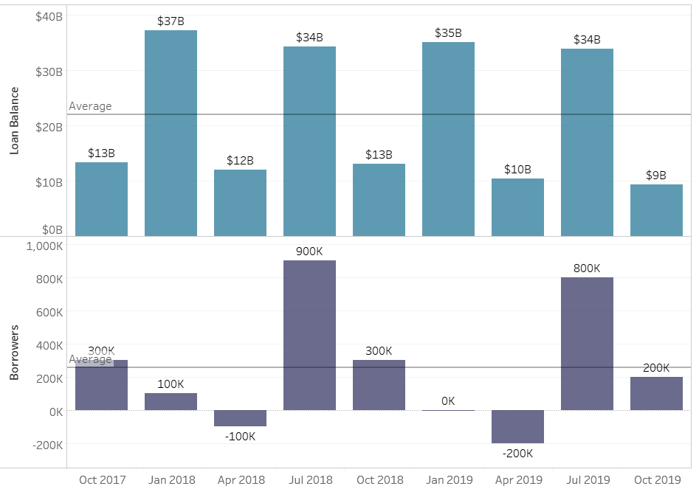

Chart note: I chose this column chart showing the loan amount increase each quarter because it was more compelling than the bar chart of line chart shown below. The numbers are so big you can’t really appreciate the growth due to the nearly flat line. I also chose to show numbers rather than percentages quarter over quarter because I felt the numbers were more shocking. I also picked colors that complemented each other (teal and purple) and clearly distinguish when I am sharing Loan Amount versus Borrower information throughout the charts.

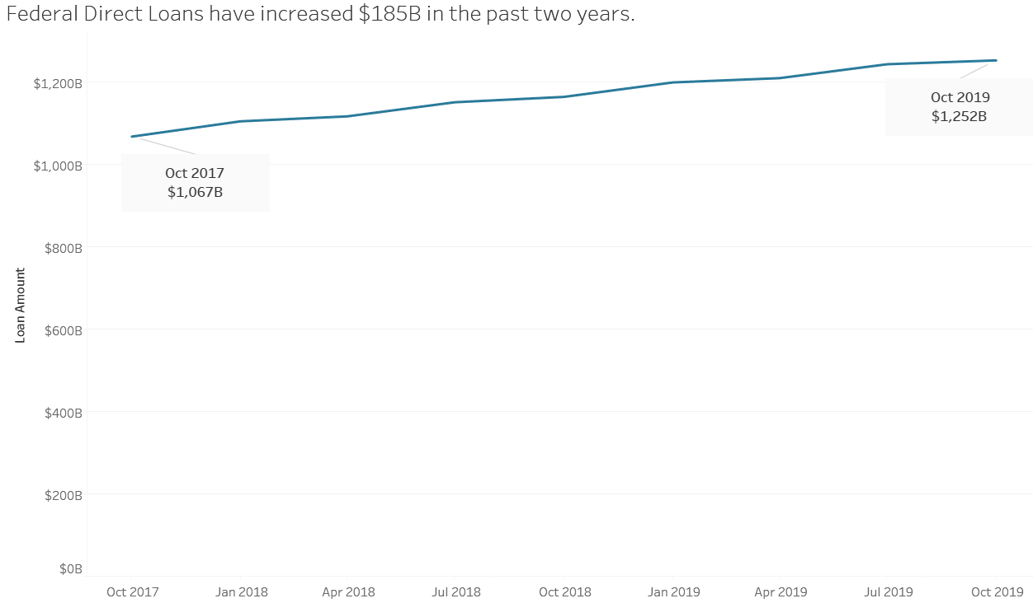

While the percent increase of borrowers has grown 6%, the average loan amount to borrowers has grown 10.7% during this time. This indicates the cost for a College Degree is increasing and students are spending and borrowing more to finance their higher-priced college degrees. While the increased cost of a College Degree is one contributor to the 17.4% increase in loan balances over two years. Another concerning, contributor is the limited amount of total student loan balance being paid back each year.

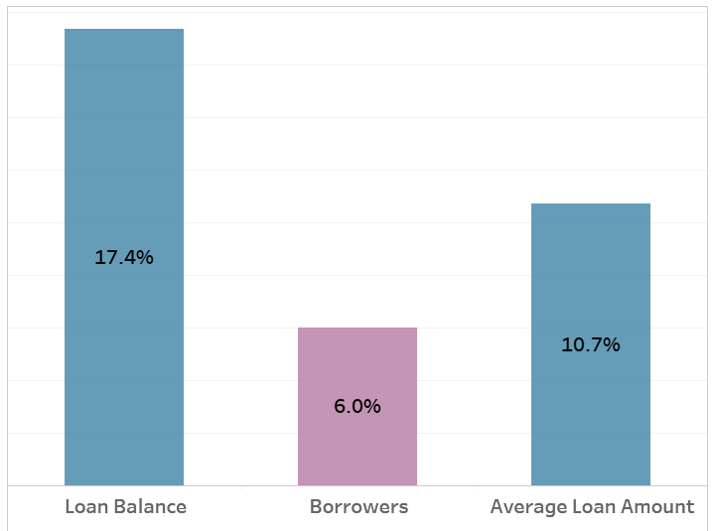

Chart note: I chose this column chart showing the percent increase of loan balance, borrowers and average loan amount side by side by side to clearly show borrowers are taking on bigger loan amounts and the loan balance is increasing even more than the average loan amount indicating there is another issue. I opted to exclude this chart because I couldn’t pull the average loan amount in too.

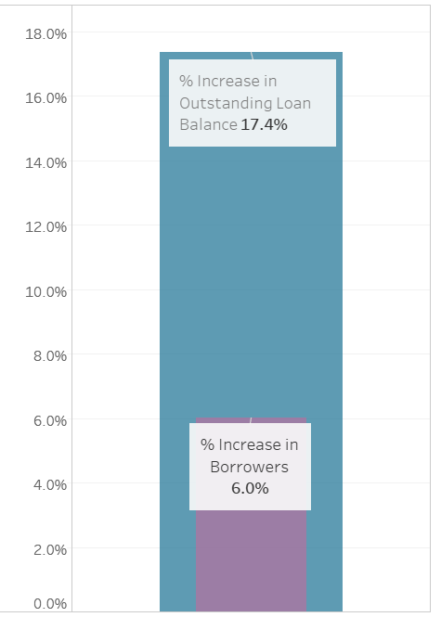

Of the $1.25 Trillion loan balance, only $638B is currently being repaid. The remaining $614B is in a postponed payment status, not being paid back each year. 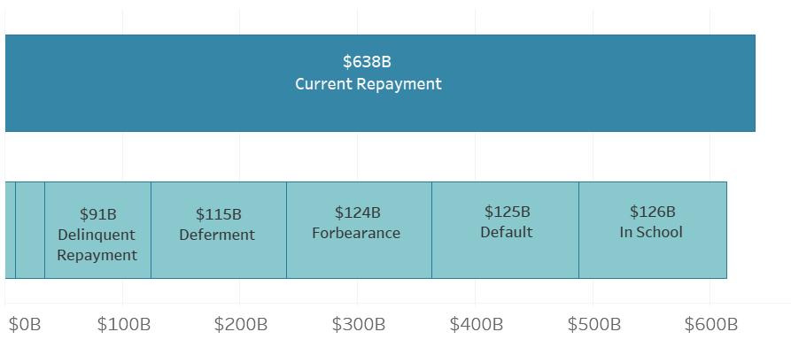

That is almost half of the loan balance is not being paid back each year, 49% is in a postponed payment status.

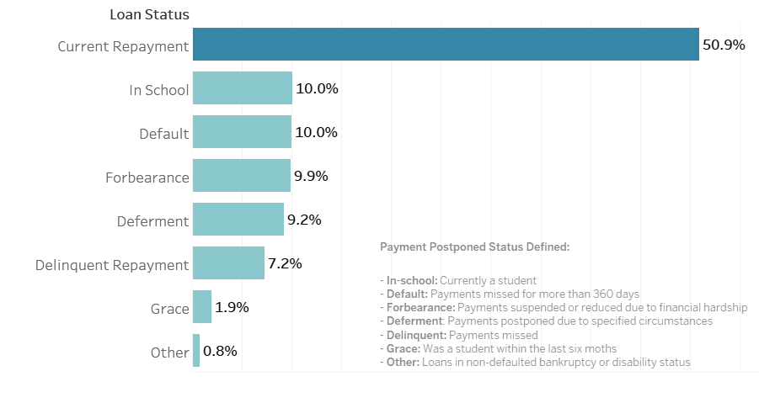

Chart note: I chose these two bar charts to highlight how much of the loan balance is currently being repaid versus in some sort of postponed repayment status. And the different types of postponement payment status. I included the postponed repayment status definitions at the bottom right of the chart in the event the reader wanted a little better understanding of the differences. For the reader who doesn’t, they can stop at the status labels and percentages.

And while 42% of borrowers are currently repaying their loans, there are 58% who are not. Even after borrowers have left school, 37% of are not able to keep their payments current. And 14.5% of borrowers have a default loan status as of 2019 which was an increase of 21.3% over 2017. The consequences of a default loan to the borrower are significant and can include damaged credit, ineligibility for future student loans, garnishment of wages, high collection fees, loss of federal income tax refunds or social security. The consequences of a default loan to a Company can include stressed workers and reduced productivity. Additionally, the increasing number of defaults has an impact on the taxpayer. The federal government spent more than $600 million in 2016 and projects costs to exceed more than $1 billion in the near future (3). Default loans also hurt the borrower’s future financial stability. If the borrower is focusing on paying back loans rather than saving for the future, the ability to retire becomes nonexistent and can become a taxpayer issue.

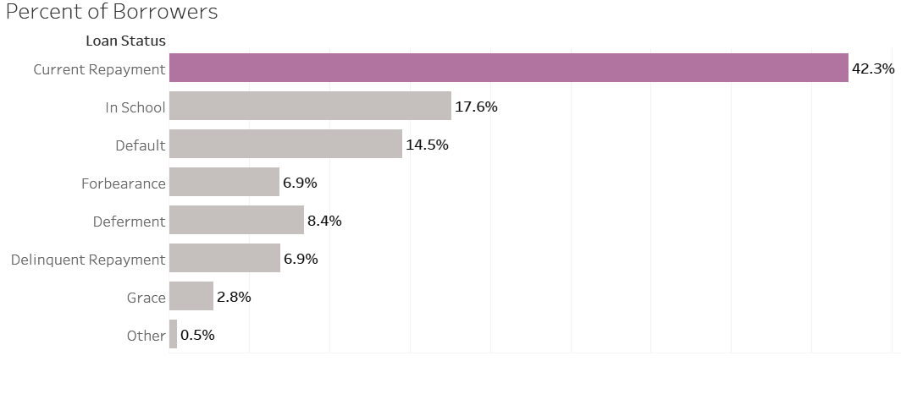

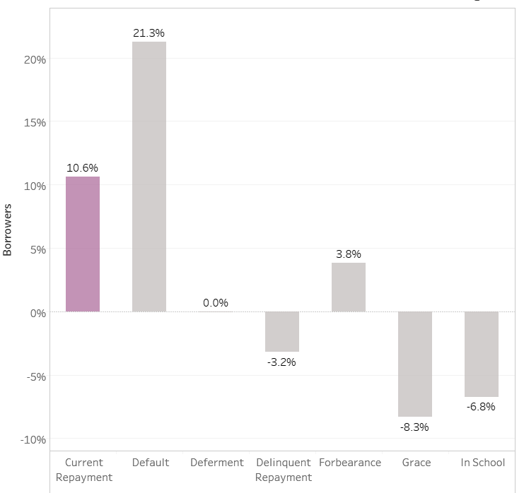

With the average loan amount increasing by about 5% each year and the average amount for 2019 being $35K, it is not surprising we have so many borrowers who aren’t able to stay current.

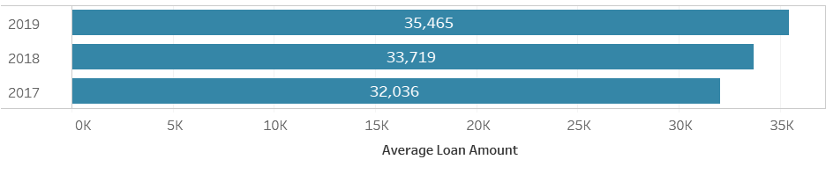

You can see by the average amount for the loans in default status that many borrowers are able to pay off a large portion of their loans before stopping payments. According to the latest loan debt statistics, student loan debt has become the second highest consumer debt category behind mortgage debt (3). 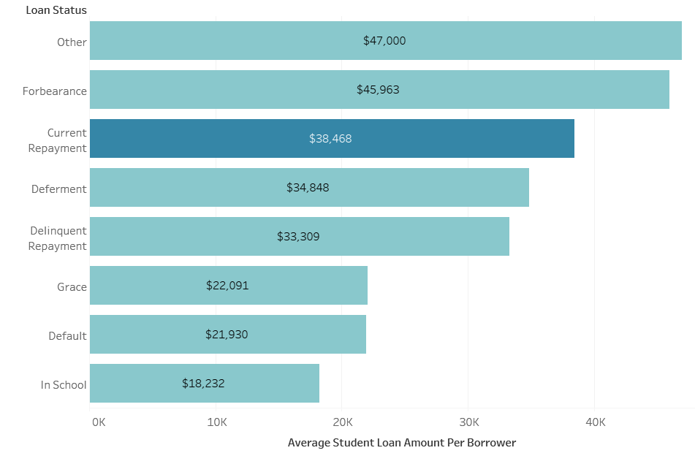

The growth of student loans is a huge problem that is going to have significant negative consequences for all of us.

Given these trends, in the next 10 years (by 2029):

* The Federal Student Loan balance will be $2.79 Trillion
* 47M borrowers will have a student loan
* The average student loan amount will be $59K

For many borrowers it is the first financial obligation they incur, leaving them with debt can be paid over a period that can be a decade or more as the average student takes 19.4 years. (3)

Borrowers are going to need help from the Companies they are working for to get these loans paid off. At SAS Institute, Inc., about 83% of our jobs require a college degree. We have about 93% of our 6,500 employees in jobs that require a degree. Considering, it takes about 19 years on average to pay back these loans and just under 15% of borrowers with loans are in default, SAS could have hundreds of employees facing financial hardship costing the company in lost productivity thousands of dollars each year in lost productivity.

**More interesting findings when looking at state data that I didn’t use in my story:**

Unsurprising, the states with the largest populations have the largest proportions of student loans. Texas, California, Florida and New York.

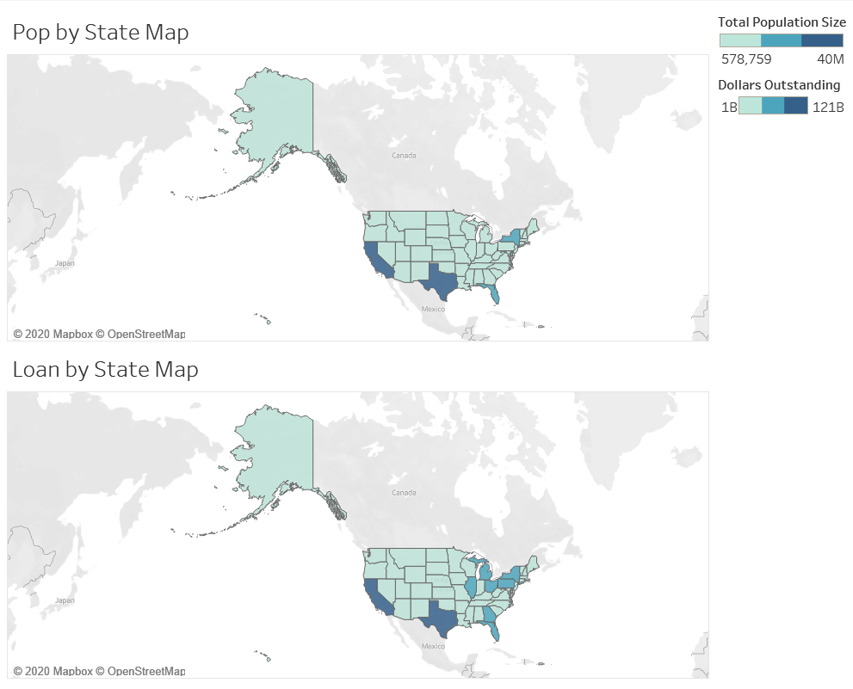

Also, not surprising but a data point that stood out using graphics was that the District of Columbia only has 5.7B in loan balances, but the average loan amount is the highest of any geo state/area at $53,926. It must be all those Lawyers and Politicians on Capitol Hill.

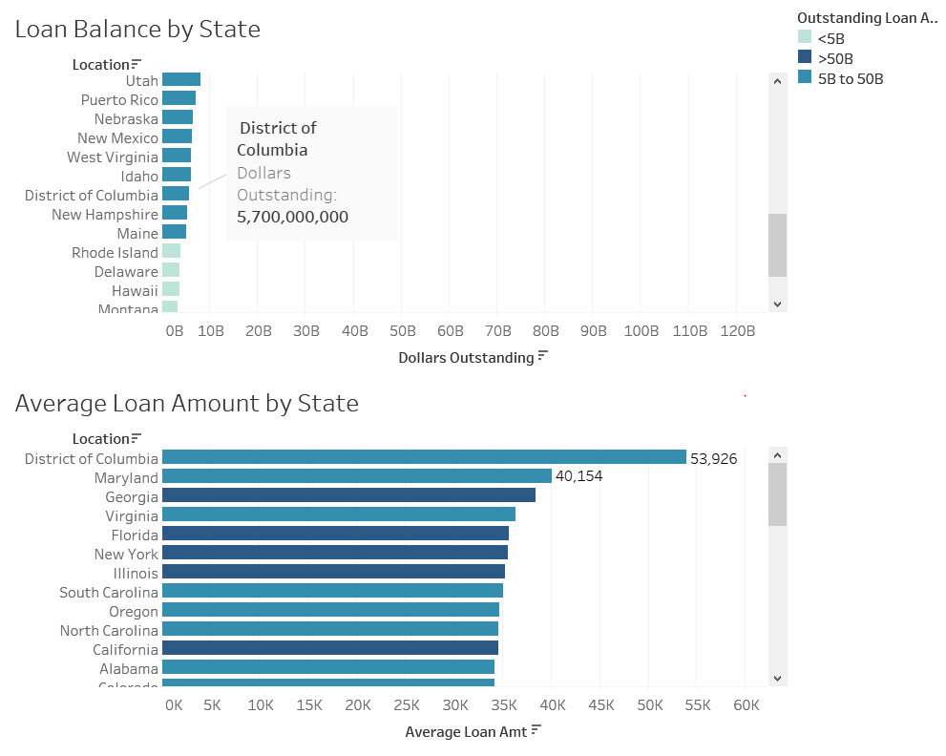

I was surprised to see NC is one of the highest states for postponed repayments relative to the loan balance amount.

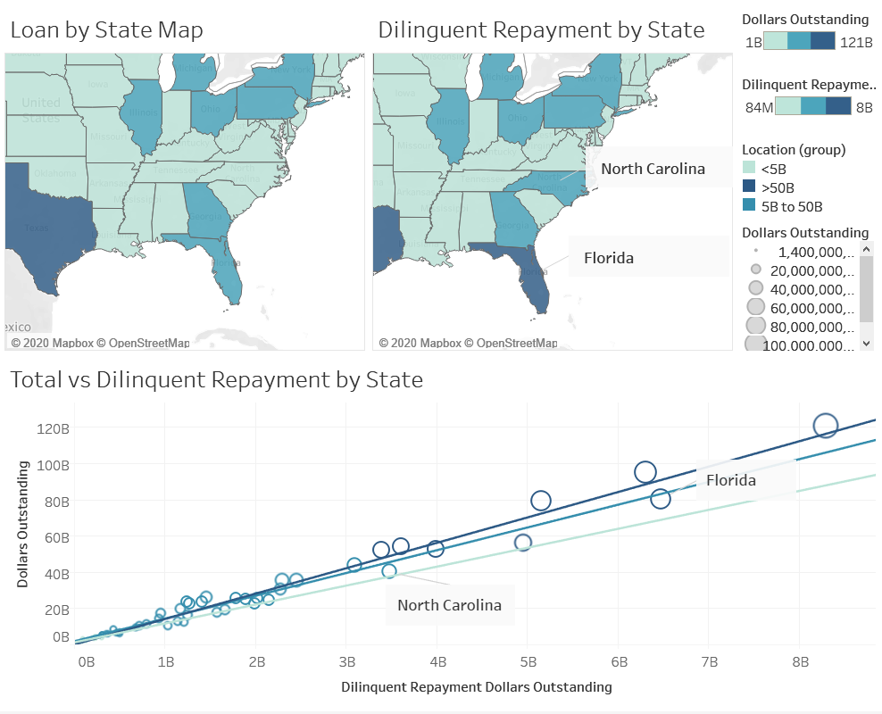

**References**

1. Student Aid (2019) Federal Student Loan Portfolio Available at: <https://studentaid.gov/data-center/student/portfolio> (Accessed 27 April 2020)
2. United States Census Bureau (2019) State Population Totals: 2010-2019 Available at: <https://www.census.gov/data/datasets/time-series/demo/popest/2010s-state-total.html#par_textimage_1873399417> (Accessed 30 April 2020)
3. Wikipedia (2019) Federal Direct Student Loan Program Available at: <https://en.wikipedia.org/wiki/Federal_Direct_Student_Loan_Program#cite_note-30> (Accessed 30 April 2020)
4. EducationData.Org (2019) College Enrollment & Student Demographic Statistics Available at: <https://educationdata.org/college-enrollment-statistics/> (Accessed 30 April 2020)
5. Blyskal, Jeff, More Companies Helping Employees Repay Student Loan Debt, 22, August, 2016, CR Consumer Reports Available at: <https://www.consumerreports.org/money/new-employee-benefit-helps-repay-student-loan-debt/>